Preparation Material

Introduction - Meeting
What does the word “meeting” mean to you? It may be meeting the expectations of a particular culture or meeting someone for the first time. What about meeting a language or way of life that you’re not used to - or meeting friends out? It could be meeting someone digitally for work or online gaming. For you it could even mean meeting others half way and coming to a compromise.
We all have daily experiences of meeting the outside world. Through these interactions we learn about our own thoughts and emotions, leading to a new and different view of ourselves, others and the world.
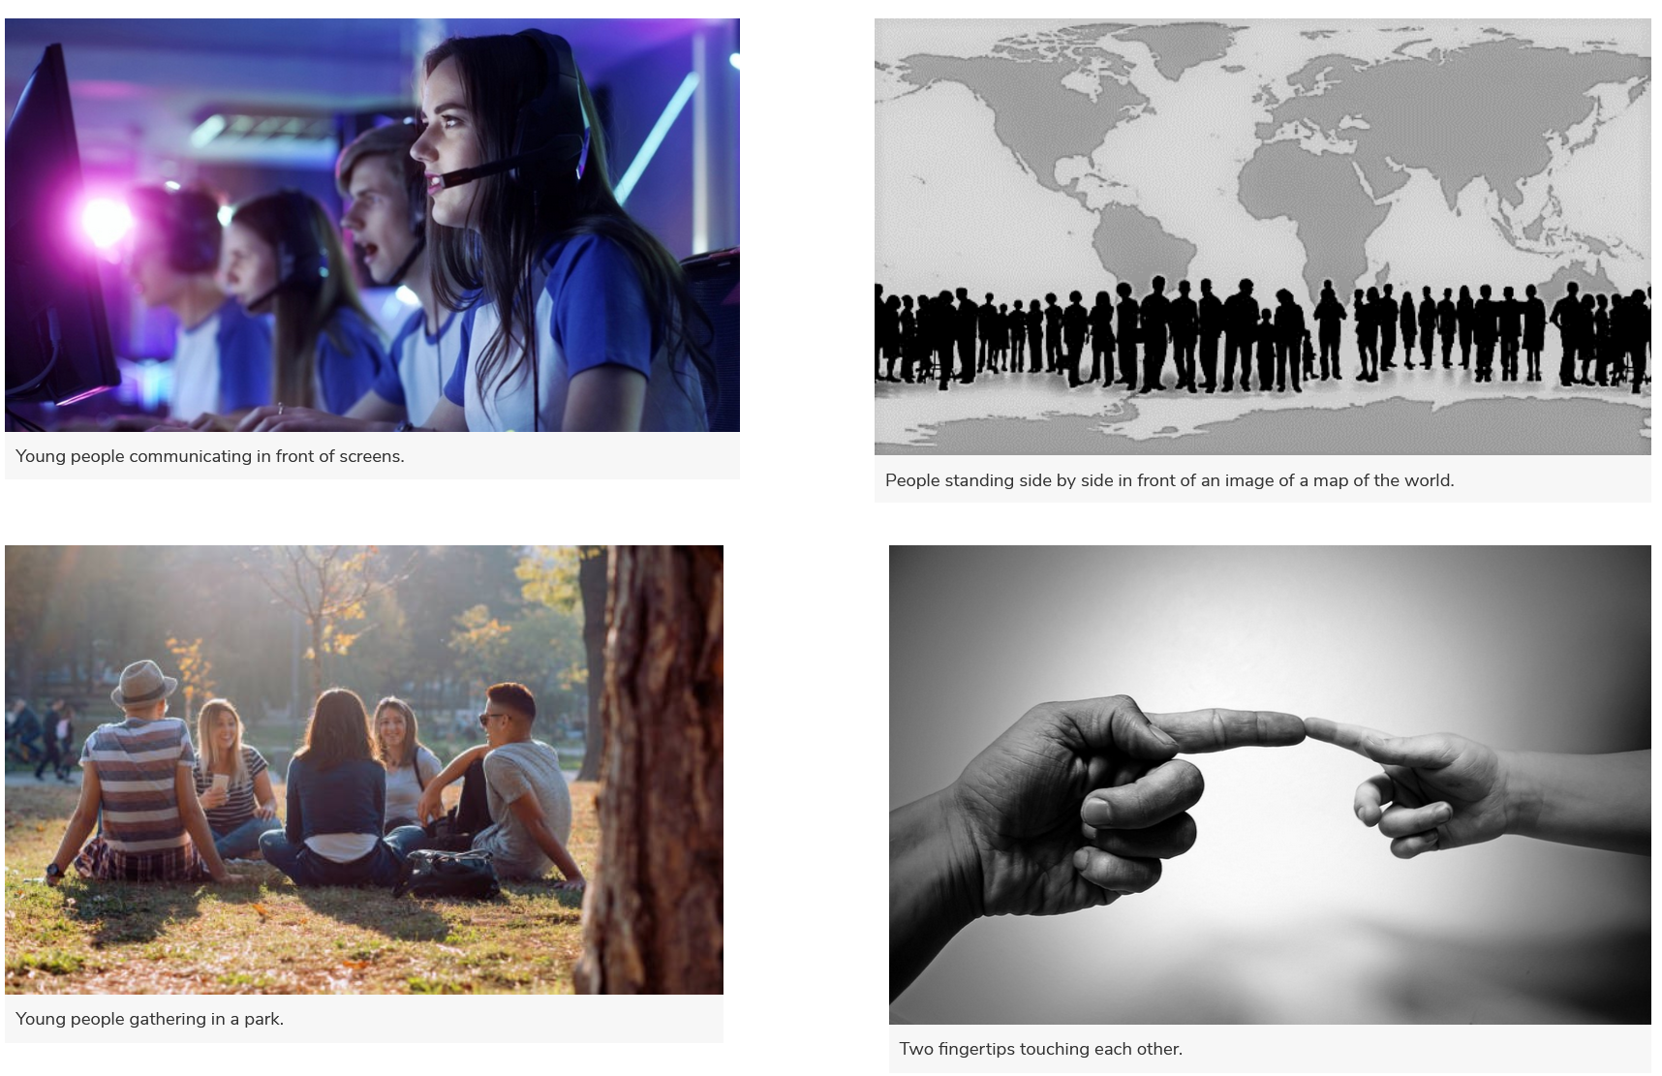

Meeting Diversity
The world is full of differences. Some are a natural part of life, while others are unjust and need to be changed. The people we meet in our lives help us to understand these differences, which then helps us to learn how to best understand and meet new people. Awareness of others is an essential part of how we contribute to making a better world. Meeting each other with respect, despite different opinions and political views, is important for a functioning democratic society. Innosanto Nagara published the book A Is for Activist with the idea that we are never too young to learn about differences, as you will see in these examples from the book:
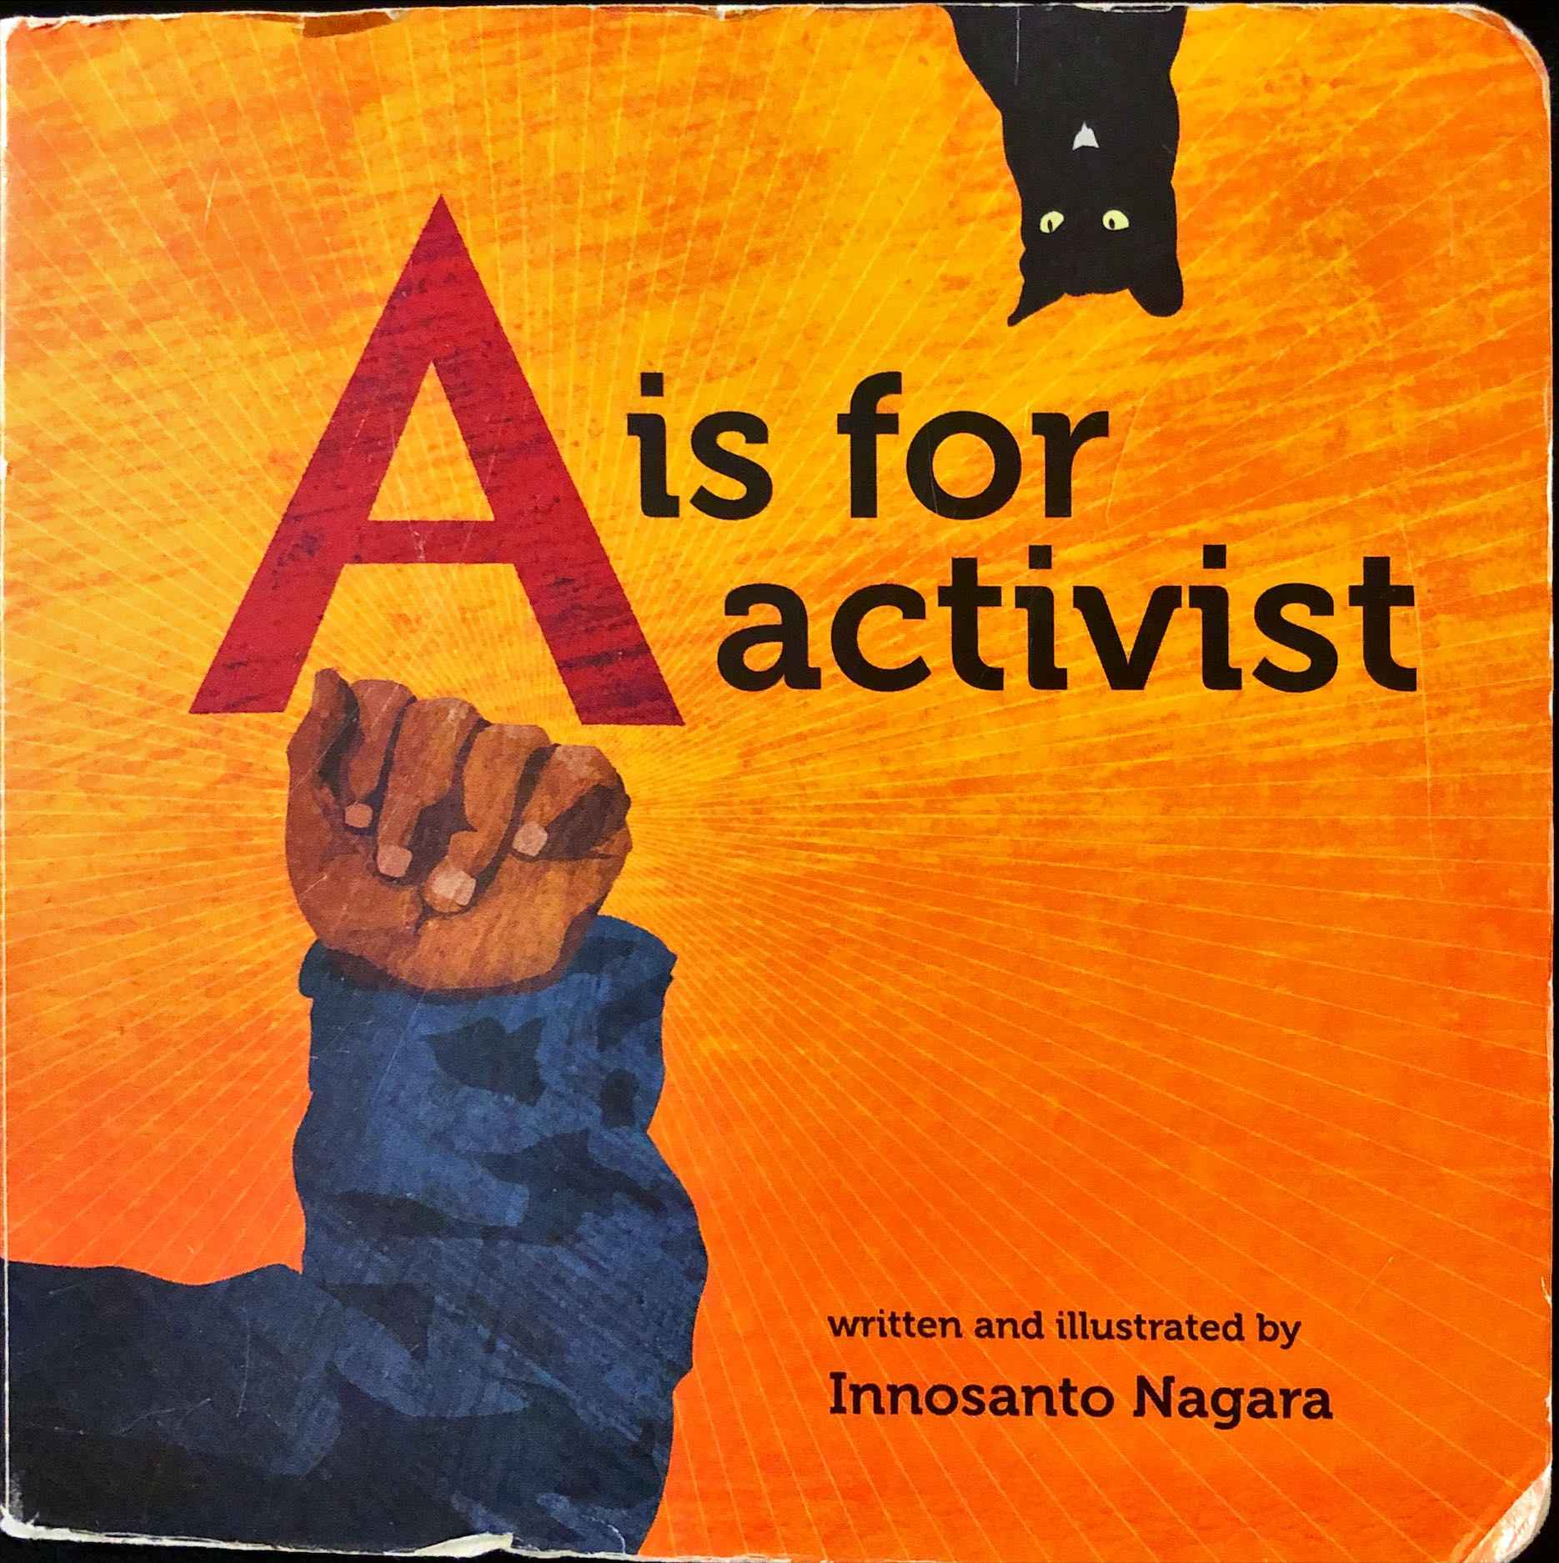 | 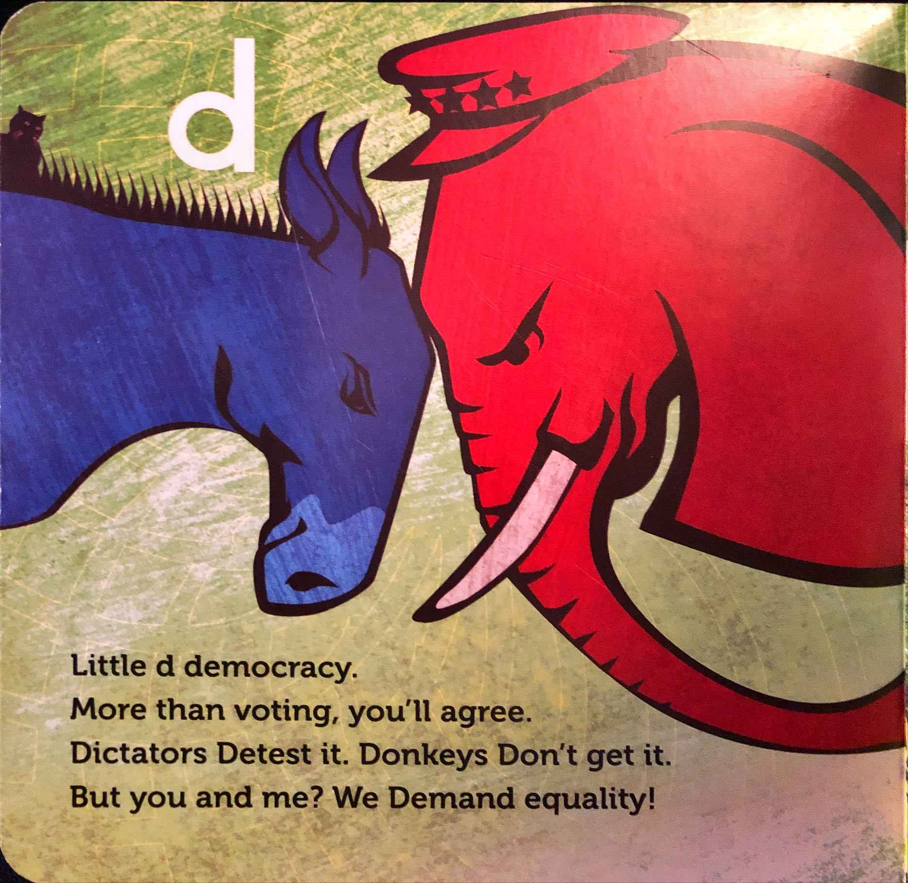
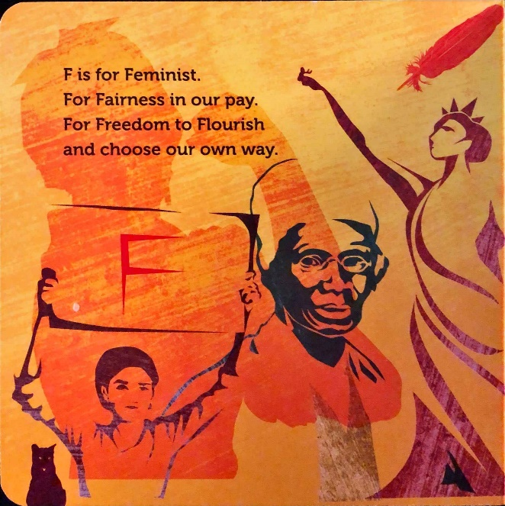 | 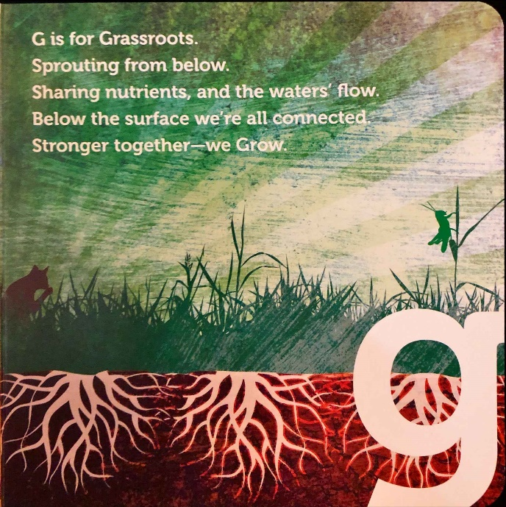
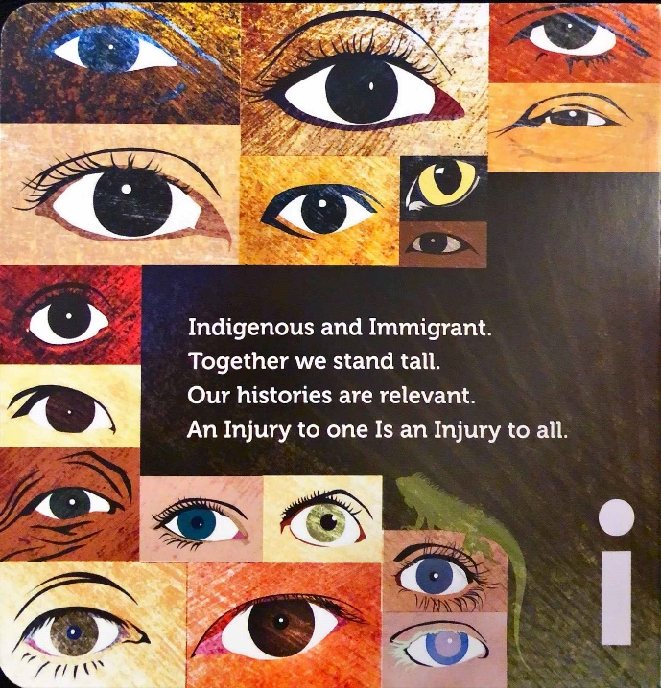 | 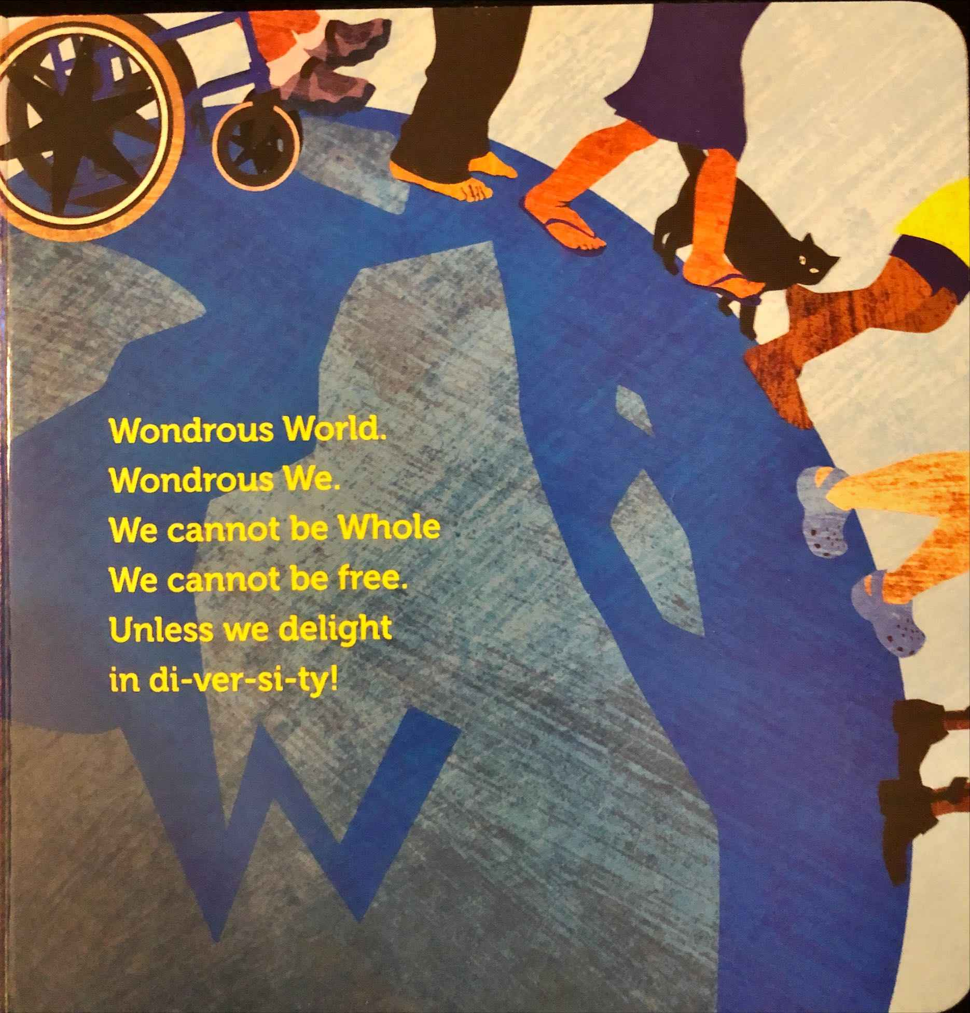

Does Meeting Virtually Contribute to Democracy?
Meeting virtually has become a common and useful way of sharing knowledge, ideas, and opinions, and for participation in decision-making. Virtual meetings have also been reported to increase participation in democratic meetings.
Studies have shown that many people lack the time, energy or possibility to participate in in-person meetings. This means that many people never get to influence decisions which may affect them and their lives. When meetings are held virtually, a wider range of participants have access to them. Meeting virtually may therefore be a more inclusive way of meeting.
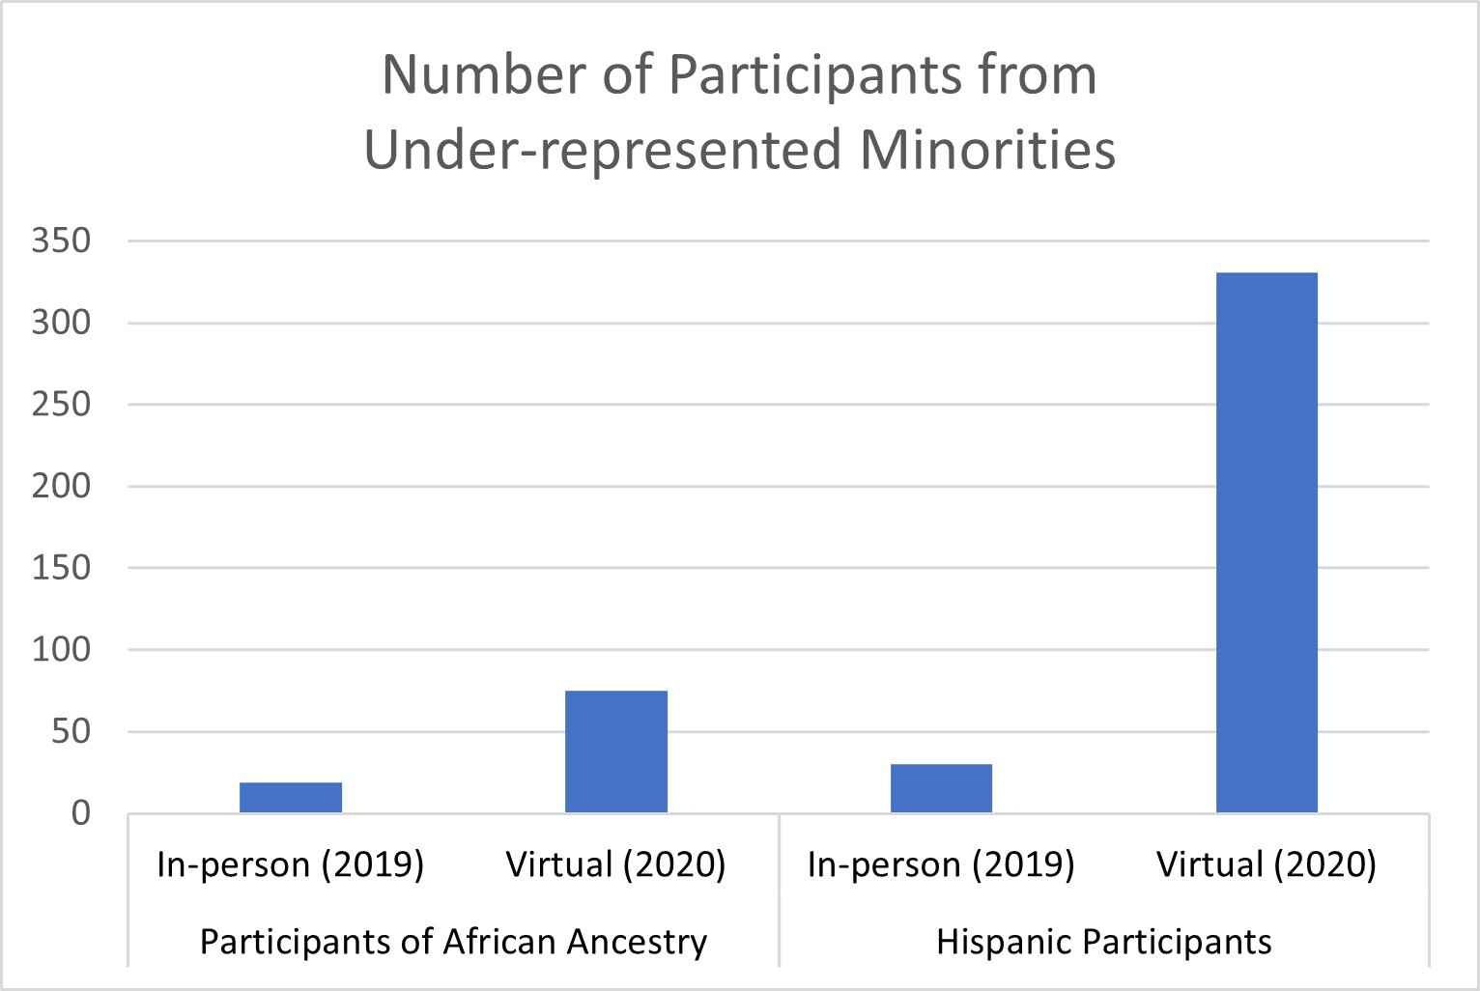Number of Participants from Under-represented Minorities. Illustration of the increasing number of African American participation (from 10 in-person in 2019 to 70 virtual participants in 2020) Hispanic participation (From 20 in-person in 2019 to 325 virtual participants in 2020).

An example of this can be found in data from a scientific conference comparing when it was held in-person (2019) versus virtually (2020). Data from these two years showed that the total number of participants rose from 374 in 2019 to 3,913 in 2020.
Meeting virtually also contributed to increased diversity in whose voices and opinions were represented. When comparing the number of participants from under-represented minorities, one found a significant difference from 2019 (in-person) to 2020 (virtual).
The minorities in question were Hispanics and people of African ancestry, and the diagram shows that meeting virtually meant a higher number of participants in this conference.
Questions of inclusivity, diversity and accessibility were also raised by the United Nations in relation to the participation of youth in local democracy last year, in the online International Youth Conference (IYC).
This conference is designed by young people, for young people to meet, and it aims to educate youth on global issues and challenges. IYC hopes to inspire youth to collectively voice their perspectives and act to achieve the Sustainable Development Goals (SDGs) of the United Nations.
One of the topics in 2022 was the inclusion of marginalized youth in communities. The panel discussed how important it is to include voices and perspectives from different groups in the work towards the SDGs.
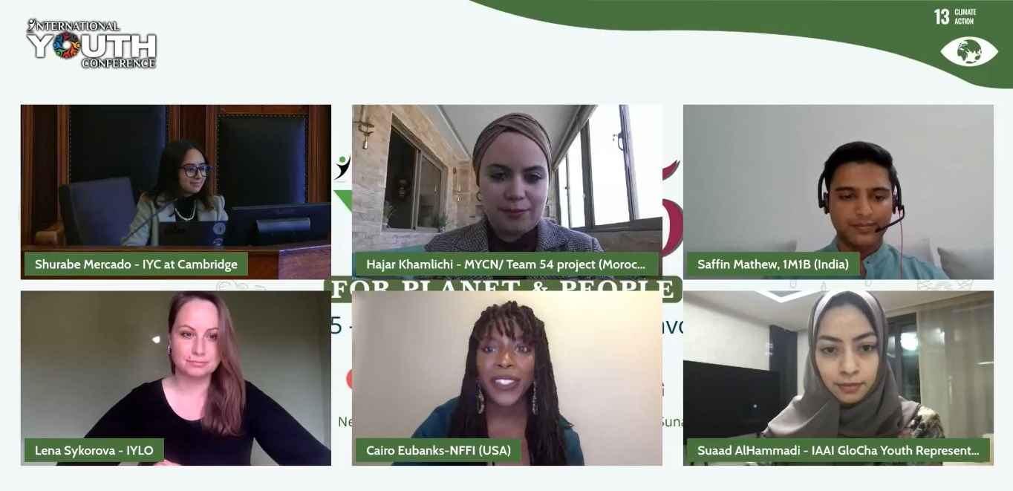Digital meeting with young people from different cultures.

As Saffin Matthew from India said: “We need to ensure that we include youth from marginalized communities, and youth at risk, in building a sustainable and better planet.”
Shurabe Mercado, seeing herself as the voice of indigenous people, argued that: “For Western people, Mother Earth must be studied, dissected and mastered. For indigenous people ... it’s literally their source of life.”
Lena Sykorova, from Austria, pointed out that in the UN system, youth are left out from many important meetings: “We have so many summits, so many UN conferences, but young people are not even allowed to be in the room.”
Having access to the meeting rooms for all people is important for individuals, to feel seen, heard and included. It is also important for democracy, since democracy means involving the whole population in decision making processes. Since meeting virtually seems to lead to improved accessibility, inclusivity and diversity, one could probably also say that it contributes to democracy. This brings great promise for the future.

From: United Nations - Civil Society (2022). International Youth Conference 5th Edition. 25-27 March 2022

1 Listening
Lyttetekstene ligger på skolens nettside for tentamen www.bjorkly.no/tentamen
Scroll deg ned til Nettsider Tentamen Engelsk

2 Reading
2A – Birthday
Peter is a popular guy and he always shows up when friends ask him to. Even though he isn't loaded he never shows up empty-handed when he is visiting his friends. He brings gifts and food. So on his birthday his friends decided to pitch in and have a surprise party for him. They also paid him back for all his generosity by fixing his motorbike that had broken down a few months earlier

2B – Two Worlds
She realised that her friends from the team didn't get along with her friends from class, as if two worlds seemed to collide whenever they were together. This made it quite awkward for her; it was as though she was stuck between a rock and a hard place. So she decided to keep the two separate, and make sure to only see one group at a time. Nevertheless, the whole thing would have been a lot easier if she hadn't let slip that her teammates made jokes about her other friends being quite dorky. This made the chances of her classmates wanting to bridge the gap far less likely.

2C – The Decision
A lot of young people struggle when it comes to deciding on what they want to do when they get older. And it is no wonder that it can be difficult to make such an important decision. How many 16- year-olds know what they are good at, what their interests are and what they would be happy doing for the rest of their lives? The choices are limitless and it’s impossible to plan for the days that are ahead. Maybe they will have children, maybe they will become ill or simply realise they want to do something else. Whatever the case, they still have to decide what school to apply to after completing secondary school....

2D – Viking Attack
The devastating Viking attack on the church of St Cuthbert sent a shockwave through Europe. The first few months of the year 793 were worrying times. Later Anglo-Saxon writers in northern England recalled how immense whirlwinds, flashes of lightning and fiery dragons were seen flying in the air’. They thought these aerial phenomena were portents of imminent disaster.

2E – The Weaving Together
You will be given the text in the question paper

2F – The Declaration of Independence
You will be given the text in the question paper

2G – Whale Rider
Nanny Flowers has just gotten a phone call about a new born baby into the family:
She put down the phone. ‘Well, Rawiri,’ she said to me, ‘you and the boys have got a beautiful niece.' All of a sudden, she put her hands on her hips and made her face grim and went to the front verandah. Far away, down on the beach, old Koro Apirana was putting his rowboat onto the afternoon sea. Whenever he felt angry he would always get on his rowboat and row out into the middle of the ocean to sulk.
‘Hey,’ Nanny Flowers boomed, ‘you old paka,’ which was the affectionate name she always called our Koro when she wanted him to know she loved him. ‘Hey!’ But he pretended he didn’t hear her and jumped into the rowboat. Well, that did it. Nanny Flowers got her wild up. ‘Think he can get away from me, does he?’ she muttered. ‘Well he can’t.’
By that time, me and the boys were having hysterics. We watched as Nanny rushed down the beach, yelling at Koro Apirana. ‘You come back here, you old paka.’ Well of course he wouldn’t, so next thing, the old lady jumped into the motorboat and scooted over to the dinghy. She gunned the motor and roared off after him. All that afternoon they were yelling at each other as she chased after him. In the end, old Koro Apirana just gave up. He had no chance, really, because Nanny Flowers simply tied his boat to hers and pulled him back to the beach, whether he liked it or not.
That was eight years ago, when Kahu was born, but I remember it as if it was yesterday, especially the wrangling that went on between our Koro and Nanny Flowers. The trouble was that Koro Apirana could not reconcile his traditional beliefs about Maori leadership and rights with Kahu’s birth. By Maori custom, leadership was hereditary and normally the mantle of mana fell from the eldest son to the eldest son. Except that in this case, there was an eldest daughter.

2H – Animal Experiments
B.F. Skinner, the world-famous psychologist, proved through his experiments that an animal rewarded for good behaviour will learn much more rapidly and retain what it learns far more effectively than an animal punished for bad behaviour. Later studies have shown that the same applies to humans. By criticising, we do not make lasting changes and often incur resentment.

2I – Bleed Hole
Have you ever noticed a tiny hole, also known as a "bleed hole", in the window in an airplane? Why has someone put a hole there, you might ask? Air pressure drops as the plane gets higher. The air pressure outside an airplane is much lower than it is inside. This difference in air pressure puts a lot of physical stress on the airplane window.
The "bleed hole" equalizes the pressure. The "bleed hole" also releases moisture from the air gap. This prevents the window from fogging up or frosting over.
2J – Hungry?
I once succumbed to the fad of fasting and went for six days and nights without eating. It wasn’t difficult. I was less hungry at the end of the sixth day than I was at the end of the second. Yet I know, as you know, people who would think they had committed a crime if they let their families or employees go for six days without food; but they would let them go for six days, and six weeks, and sometimes sixty years without giving them the hearty appreciation that they crave almost as much as they crave food.

2K – The Cherokee Immersion School
The Cherokee Nation is the largest tribe in the United States. In 2001, the Cherokee Immersion School was started as a Cherokee language preservation program with 26 students and four staff members. Today, the school has grown to about 110 students in grades pre-K through 8th grade. The curriculum has Oklahoma Department of Education grade level standards, but the instruction is taught exclusively in the Cherokee language, both written and spoken.

3 Mediation – Meeting Challenges
Lytteteksten ligger på skolens nettside for tentamen www.bjorkly.no/tentamen
Scroll deg ned til Nettsider Tentamen Engelsk

4 Interaction – Learning From History

A teacher at your school has set up a group chat in English class to encourage students to share their thoughts with the rest of the group and discuss things they learn.

Michael Tuesday 12:05
I was so shocked when the teacher showed us that presentation yesterday. You know, about how indigenous children in Canada and Australia were forced to stay in schools where their language and culture were forbidden. This is so different from here in Norway, where we are taught to accept each other's different cultures. I am glad I live here, where we accept other cultures and ways of living. Don't you agree?

Charlotte Tuesday 12:08
Well, I believe you're up for a history lesson here. Haven't you heard that the same thing happened to the Sami people in Norway? Sami language was forbidden, and the culture was seen as inferior and heathen. My grandmother attended such a school. She says that she always felt that other people looked down on her. Now she is proud to wear her Sami clothes, but she sometimes sighs when she hears how some Norwegians treat minorities. “It's how we were treated when we were children,” she says. So, I don´t think we're as accepting as you believe.

Thomas Tuesday 12:12
What about Pride, and the fact that all Norwegian pupils now learn about Sami culture? You heard what the teacher said, about Orange Shirt Day in Canada and the National Sorry Day in Australia, to remember what happened at these schools. Isn't that a sign that we all have learned from history, and that no one should need to feel inferior?

