TEKSTHEFTE FAGDAG ENGELSK

8. klasse

1 Listening
Lyttetekstene ligger på skolens nettside for tentamen www.bjorkly.no/tentamen
Scroll deg ned til Nettsider Tentamen Engelsk og finn din klasse.

2 Reading

2A – Schools around the world
Classrooms around the world are very different. Some are outdoors and some are indoors. Some have a lot of equipment, others have very little. In many countries, there is not enough money to build schools. Some kids have classes under the trees in their village. Others use tents as classrooms. On the following pages you will see six photographs of teachers and pupils in classrooms around the world.

2B – School uniforms
In many countries, schoolchildren wear school uniforms. Each school has its own uniform. Typically, girls wear a skirt and blouse, and boys wear dark trousers and a shirt and tie. In Norway, pupils do not wear uniforms, but I think they should. There are many good reasons why pupils should wear school uniforms.
School uniforms make life a lot easier. They save time and money. If you wear a school uniform, you do not need that many clothes. Also, you do not have to worry about what to wear every morning or argue with you parents about your clothes.

2C – The right to attend school
The UN Convention on the Rights of the Child says that every child has the right to go to school. Sadly, millions of children around the world do not have this opportunity. Poverty and conflict prevent them from attending. Many of these children have to work to help support their families. Others, especially girls, stay home to watch younger siblings and do chores. In some places, it is too dangerous for children to attend school. Thousands of schools have closed because of war and conflict. Every child deserves an education.

2D – The Dragon
You will be given the text in the question paper

2E - Jenny’s Letter to Jason
You will be given the text in the question paper

2F – Physical activity of Canadian children and youth
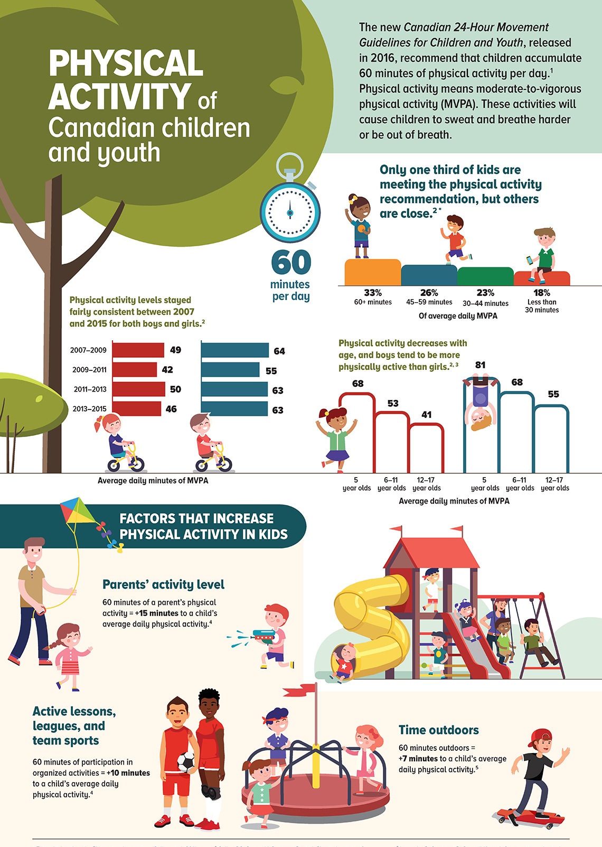

3 Mediation – The red fox
Lytteteksten ligger på skolens nettside for tentamen www.bjorkly.no/tentamen
Scroll deg ned til Nettsider Tentamen Engelsk og finn din klasse.

4 Interaction – Animals living in zoos (public forum)
WildLifeLover17 10 hours ago
I’ve always loved animals, and visiting zoos has been one of my favourite things to do since I was little. I like seeing species I’d never get the chance to see in the wild, and I honestly think zoos can teach people a lot. But lately I’ve been thinking more about the downsides… Some animals seem stressed or bored, and the enclosures sometimes just feel too small for what they really need. I’m torn — are zoos helping animals or hurting them? What do you guys think?
EcoKid 7 hours ago
I get what you mean. I used to think zoos were purely good, but after watching some documentaries, I started questioning it. A lot of animals travel huge distances in the wild, and obviously they can’t do that in a zoo. Even if the caretakers try their best, it’s still not the same as living in their natural habitat. I think sanctuaries are better because their goal isn’t to entertain people, just to give animals as natural a life as possible.
CityExplorer 6 hours ago
I actually think many modern zoos do important work. Yes, some older zoos have horrible enclosures, but the newer ones focus on conservation. Some endangered species literally survive today only because zoos have breeding programs. And the educational value is real — seeing an animal up close makes people care more about protecting it. I’m not saying everything is perfect, but I feel like without zoos, a lot of species would be worse off.
AnimalNerd 3 hours ago
Honestly, I’m kind of in the middle. I agree that animal welfare should come first, and if a zoo can’t give an animal enough space or proper enrichment, then it shouldn’t keep that species at all. But I’ve also met zookeepers who genuinely care and work super hard to keep the animals healthy and mentally stimulated. I think zoos should be held to much stricter standards, and only the ones that meet them should continue to operate.

Sources
2F – Physical activity of Canadian children and youth
https://www150.statcan.gc.ca/n1/pub/11-627-m/image/11-627-m2017034-eng.jpg
3 – The red fox
https://lille.snl.no/rev
4 – Animals in Zoos
www.ChatGPT.com

